**ACKNOWLEDGEMENT**

We take this opportunity to thank all the people who have provided many forms of help and support to create this project. Firstly, we express our gratitude and thanks to our project mentor Prof. Arnab Hazra for his invaluable guidance and assistance.

We would also like to convey our heartfelt thanks to Prof. Prosenjit Das, HOD, Department of Computer Science and Engineering for giving us the opportunity to do this project.

Lastly, this team of 5 members who are very cooperative and dedicated towards the successful completion of this project.

Chapter - 1

**INTRODUCTION**

**1.1 Objective**

An android based mobile application for group as well as individual expense tracker. This application makes it simple and easy to keep record of the expenses, one’s budget and the savings. For an out-trip with friends or families, this application shows a way of settlement among the members, thus makes money management much easier and handy.

**1.1 About the Project**

This mobile application is for keeping the records of all the expenses during a trip for a group of people (both family or friends), including the shares of each member, how much one paid and is yet to pay and also allows us to keep an eye on our budget so that we don’t need to look for a calculator every now and then before every next move. At the end it makes a balance sheet on its own and provides us the knowledge that who owes money to whom and keeps us away from that hours long calculation.

Also there is an individual expense manager where we can add, delete, edit and view our daily expenses. This module also keeps track of the individual’s budget limit and his savings thus providing a way to manage the financial account of a working person.

The main theme is that the application is both for individual or group of individuals.

**1.2 A Brief Description**

This application, Expense Bandhu, consists of two main modules:

* Individual
* Group

**Individual:** Here one can add the income and set the budget. Further he/she can add expenses, edit expenses and even set reminders telling how much he/she has spent, notifying if he/she has reached the budget limit. He will also get a reminder everyday on a specified time if he forgot to add any expense for that day. One added feature is that at the end of every month one can compare the expenses of current month with the previous ones. Also there will be a chart showing expense for particular items.

**Group:** In this module, we will have the option of adding the name of the trip. Here both a group of friends as well as a group of family friends can have the entries. For families we will have a representative and number of members for each family while for a group of friends we will just add the name of the members. There one would get the option of adding the number of members, updating them and displaying them and in the end gives a balance sheet. We will also have a limit set for each person in the group and can have multiple payee for an item. There will be a display page which shows how much money has been spent so far and who have paid for what. Once the tour ends the balance sheet gives an analysis who owes how much to whom.

Chapter - 2

**2.1 Existing System**

One of the existing applications we have is Tricount which takes into consideration expenses on a group basis. It has options to add members for an event and if the event is subdivided into several activities, one participant can pay the complete amount for an activity at a time. Likewise for different activities in the event, different members can pay for everyone at a time. At the end the calculation is made for the balance of each participant and for the settlement among group members of the event.

**2.2 Issues**

For the above app the most important problem is that there is no boundary limit. An individual can have a certain amount of money and so he/she can spend only that much. But here in Tricount infinite number of activities can be added, without considering which member is left with how much money.

Also, if multiple families are on an outing, the payment should be made by one representative of the family; there is no point in adding each family member’s name. If there are, say, 5 families each having 5 members; that means we will have to add 25 members which will make things complex.

**2.3 Proposed System**

Expense Bandhu will be suitable for keeping a track of both individual and group expenses. Additional features include adding a budget, so say if any participant is nearing his/her budget limit, they will immediately get a notification or alert on how much amount they are left with. Similarly, the personal expense manager will have a field for adding one’s income, budget and thus calculating the savings.

In case of events involving more than one family, we will have option to add one representative from a family, and also total number of members in the family. After this the calculation will be made with respect to total no. of members attending the event and then balancing the payment accordingly for each family.

Also we have an extra feature of individual expense manager system where a user can set his own income, add his savings target and he will get an alert once he crosses his specified limit. He can add, edit, update his expense and viewing can be a comparative view or as a whole for the month.

**2.4 Goals of the Project**

* To make an application that balances the expenses among a group of people as well as acts as a personal expense manager.
* To reduce the headache of paperwork calculations after a trip.
* A simple and easy to use application.
* To make both group and individual expense manager in one app.
* An app that organizes all your expenses at one place.

**2.5 Technologies Used**

Programming language:

Database:

Tools Used:

**2.6 Software Requirements**

Operating System: Android

Version:

**2.7 Hardware Requirements**

Chapter - 3

**3.1 Work Flow Diagram**

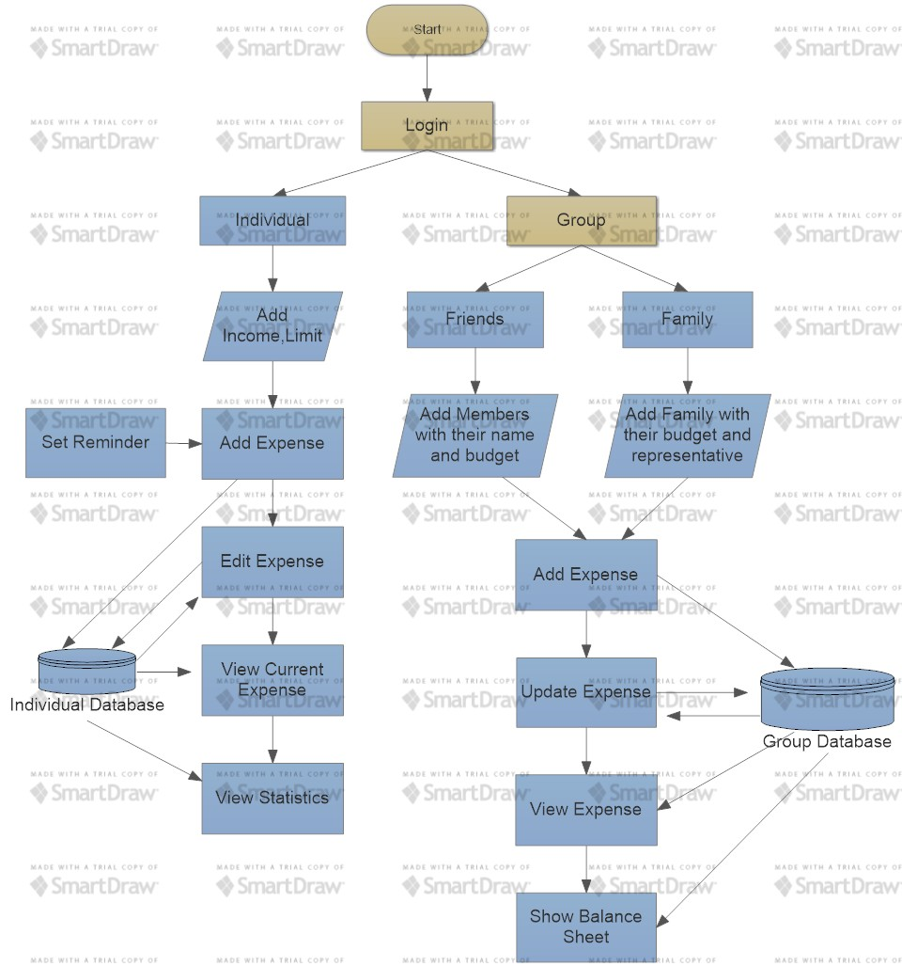

**3.2 Use Case Diagram**

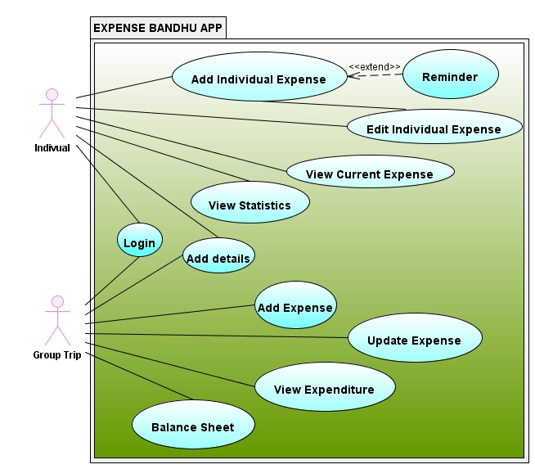

Chapter - 4

* 1. **Future Improvements and Developments**

This application will work efficiently having the said details. However, more functionalities can be added in the future. This includes:

* Settlement among the members by a suitable payment mode like Paytm.
* Setting and using your desired currency.